Assignment No - : 07

Que 1-: Write a Query that Counts all orders for october 3.

kd2_83598>select count(odate) from orders
-> where odate='1990-10-03';
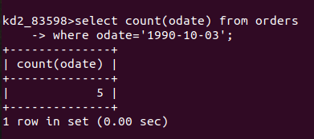

Que 2 -: Write a query that counts the number of different non null city values in the Customers Table.

kd2_83598>select count(city) from Customers
-> where city is not null;

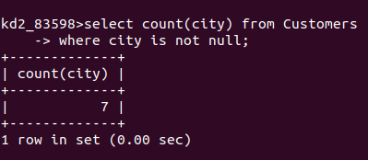

Que 3 -: Write a query that selects each customers smallest order.

kd2_83598>select Cnum,min(amt) from orders
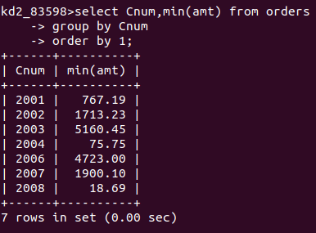
-> group by Cnum
-> order by 1;

Que 4 -: Write a Query That Selects the first Customer in alphbetical order whose name begins with G.

kd2_83598>select Cname,Cnum from Customers
-> where Cname like 'G%'
-> order by 1;
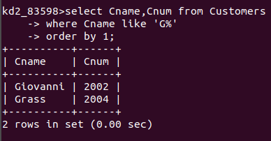

Que 5 -: Write A query That Selects the highest Rating in each city .

kd2_83598>select City,max(Rating) from Customers
-> group by city;

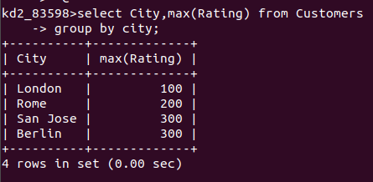

Que 6-; Write A query that counts the number of salespeople registering orders for each day ( If a Person has more than one order on given he should counted at only once.)

kd2_83598>select salespeople.Snum,count(distinct odate) from orders,salespeople
-> where salespeople.Snum=orders.Snum group by Snum;

